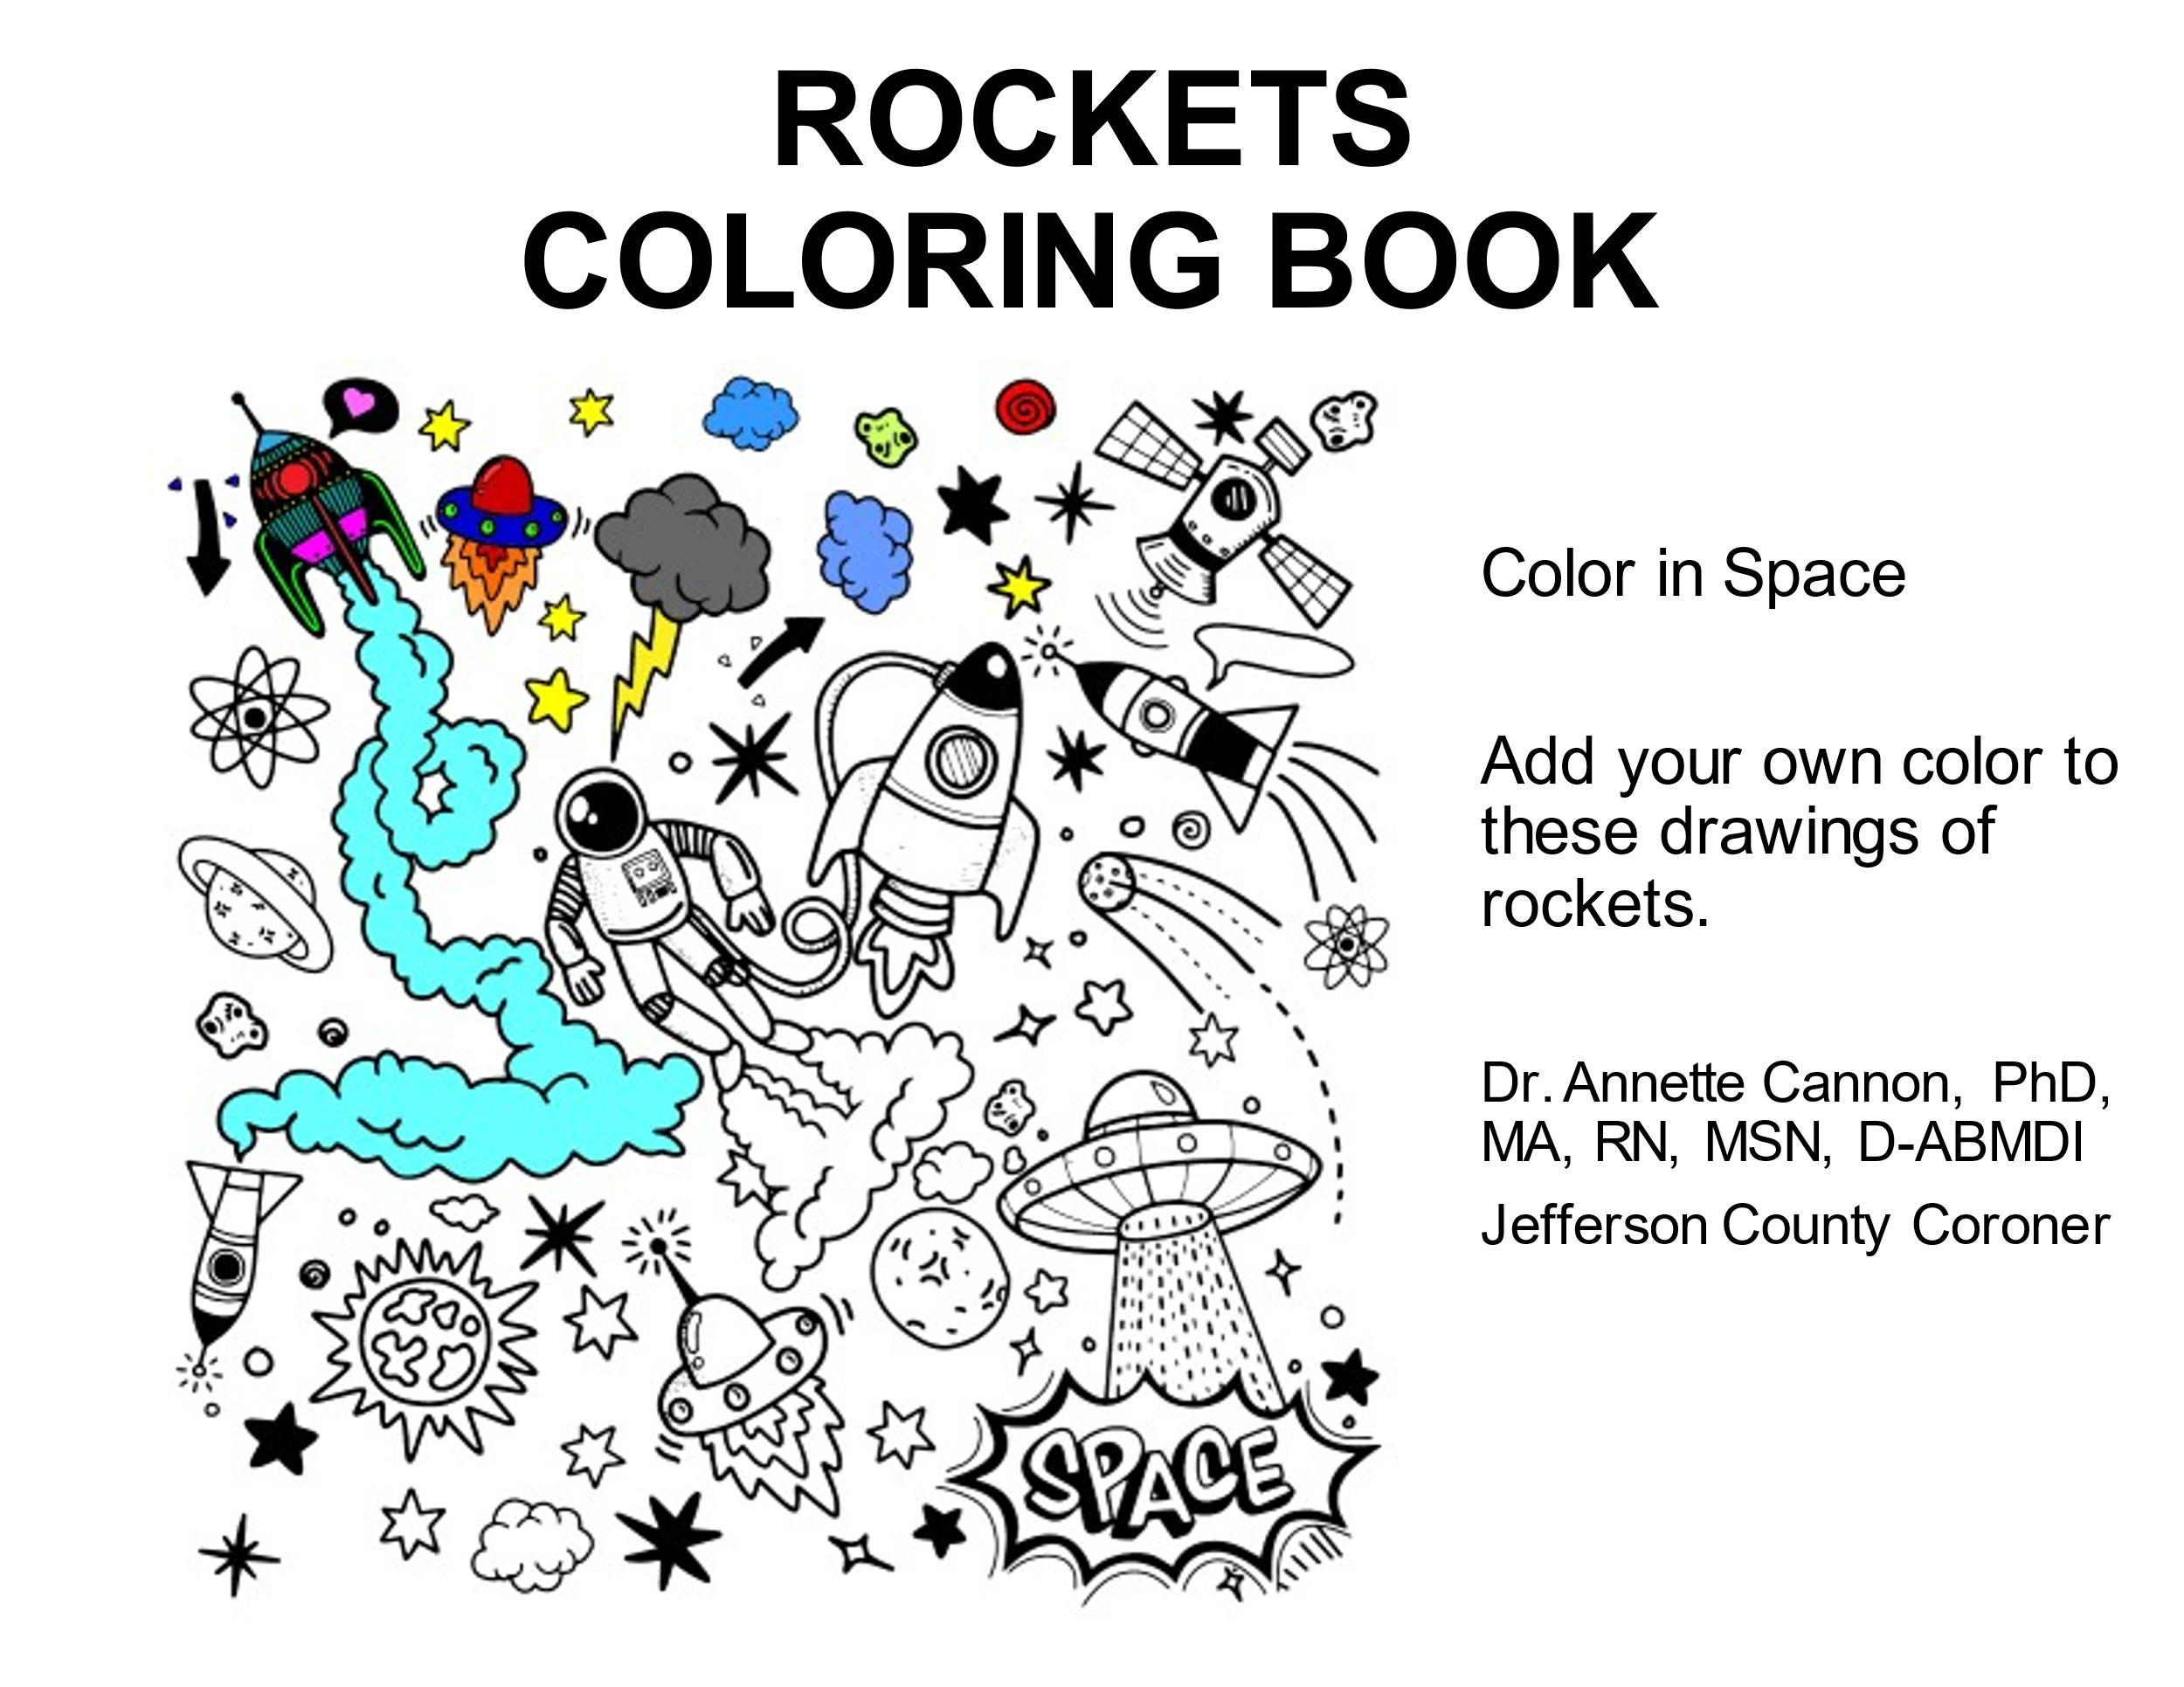
Reference: Microsoft 365, Online Templates and Themes. 2021

Reference: Microsoft 365, Online Templates and Themes. 2021

Reference: Microsoft 365, Online Templates and Themes. 2021

Reference: Microsoft 365, Online Templates and Themes. 2021

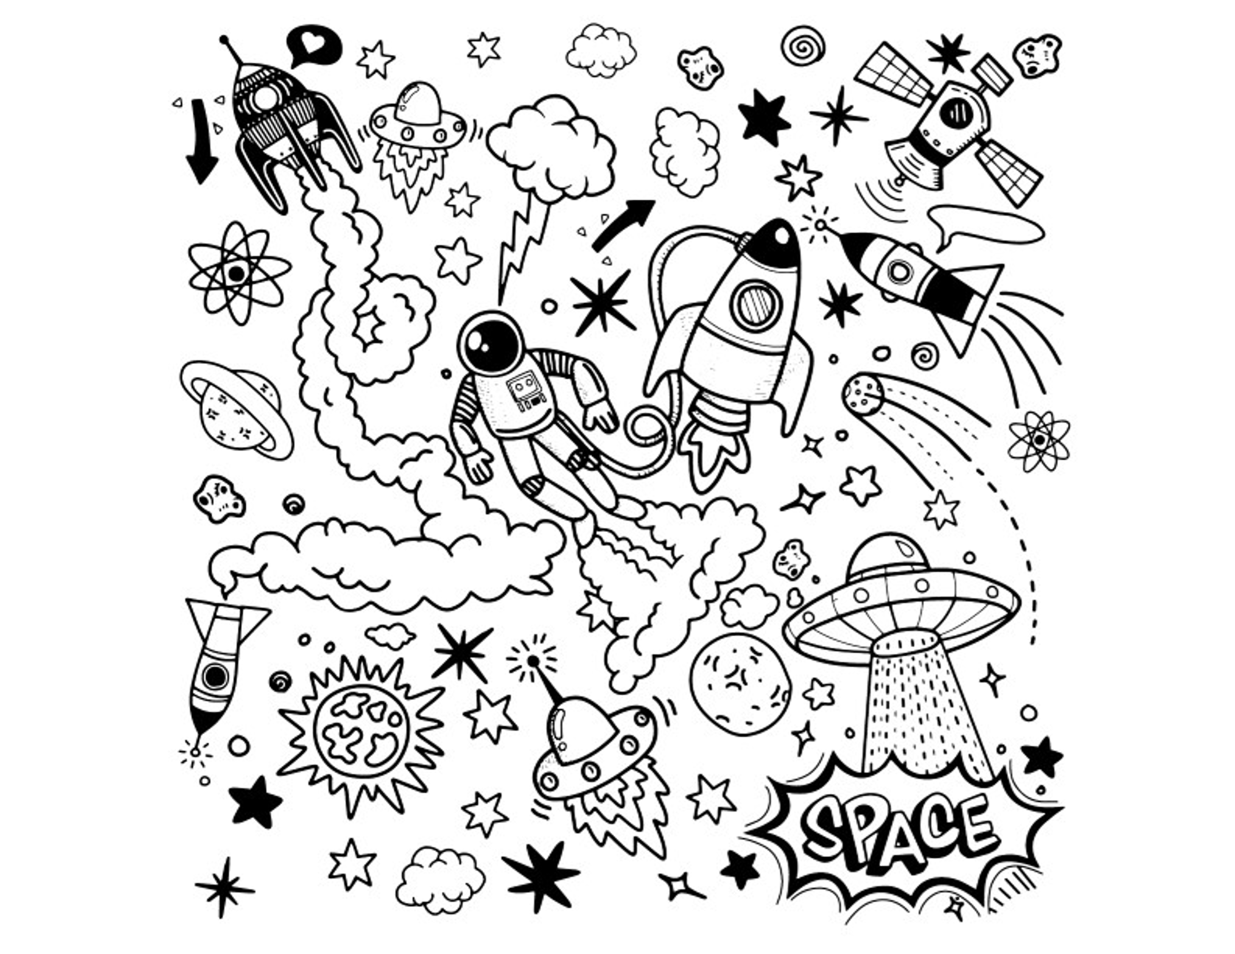
Thank you.
Dr. Annette Cannon, PhD, MA, RN, MSN, D-ABMDI
Jefferson County Coroner
Reference: Microsoft 365, Online Templates and Themes. 2021

